DEPARTMENT OF BASIC SCIENCES AND ISLAMIAT
University of Engineering and Technology, Peshawar Campus

Linear Algebra (BSI-111)
Assignment NO.2

Q1 (a) Discuss:
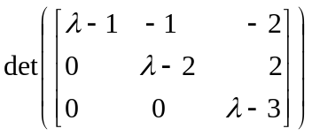

(b) Construct a linear system of equations to determine a quadratic
P olynomial 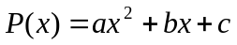 that satisfies the conditions

Q2 a) A study has determined that the occupation of a boy as an adult, depends upon the occupation of his father and is given by the following transition matrix, where P = professional, F = farmer, and L = laborer

Father’s occupation
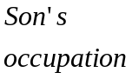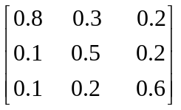
Thus the probability that son of a professional will also be a professional is 0.8 and so on.
- What is probability that the grandchild of a professional will also be a professional?
- In the long run, what proportions of the population will formers?
(b) A ship is being pushed by a tugboat with force of 300 pounds along the negative y-axis while another tugboat is pushing along the negative x-axis with the force of 400 pounds. Find the magnitude and sketch the direction of the resultant speed?

Q.3 | (a) | Discuss linear transformation and linear operator. Give at least three names of some well-known of linear transformations.
 | (b) | Sketch the image of the given point p or vector u under the given Linear  Transformation L , 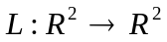is a counterclockwise rotation through 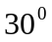  P(-1,3)
Q.4 | (a) | Use the substitution scheme and the matrix A and its inverse given by  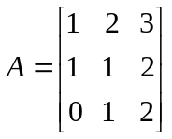 and 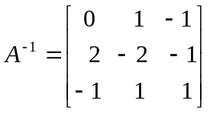  Code the massage SEND HIM MONEY
 | (b) | Decode the massage 67 44 41 49 39 19 113 76 62 104 69 55.
Q.5 | (a) | Find a line that passes through the point (-2,5,-3) and is perpendicular to the  Plane 2x-3y+4z+7=0.
 | (b) | Find an equation of the plane passing through the given three points (0,1,2)  (3,-2,5) ,(2,3,4)  Q6 (a) Let 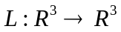be the linear transformation defined by  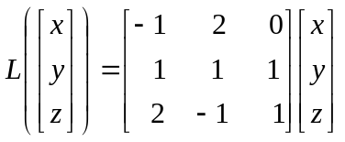. Is 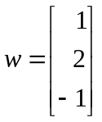 in range L?  (b) Find all constants a such that the vectors (a, 2) and (a,-2) are orthogonal.

